|  |  |
| --- | --- |
| Date | 18 June 2025 |
| Team ID | LTVIP2025TMID30187 |
| Project Name | Optimizing User, Group, and Role Management with Access Control and Workflows |
| Mentor Name | Dr Shaik Salma Begum |
| Maximum Marks | 4 Marks |

# **Optimizing User, Group, and Role Management with Access Control and Workflows**

## Milestone 1: Understanding the Problem

### Problem Context:

In a small project team setup, such as one involving a Project Manager (Alice) and a Team Member (Bob), inefficient handling of user roles, group definitions, and permissions often leads to confusion in task assignment and accountability. The current system does not support structured workflows or role-based access, resulting in overlapping responsibilities and security gaps.

## Milestone 2: Goal Identification

### Objectives:

* Define clear user roles (e.g., Manager vs. Contributor)
* Restrict actions using role-based access control (RBAC)
* Automate workflow stages like task creation, assignment, completion, and closure
* Improve accountability via audit logs and notifications

## Milestone 3: Instance Setup on ServiceNow

* Created and activated a ServiceNow Developer Instance from [developer.servicenow.com](servicenow)
* Logged in using the instance credentials
* Verified the environment for custom development

## Milestone 4: Create Update Set

* Navigated to: **Local Update Sets**
* Created a new update set: AccessControlWorkflow
* Made it current for capturing all customizations

## Milestone 5: Role Definition Table Creation

* Created a new table: Role Definitions
* Fields included: Role Name, Permissions, Description
* Configured auto-numbering and number maintenance with prefix: RWF

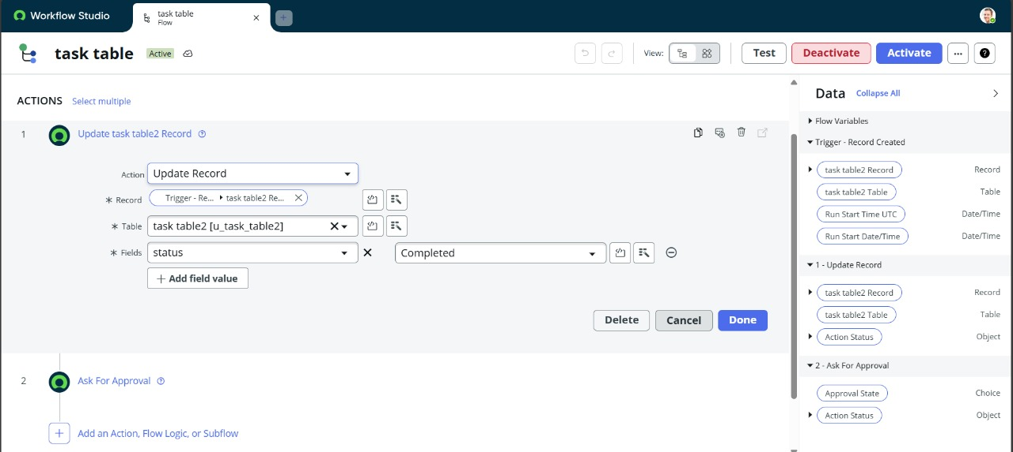

## Milestone 6: User and Group Table Creation

* Created two tables:

**User Management** – stores user details and assigned roles

**Group Management** – stores group names, members, and linked permissions

* Linked Users to Groups and Roles via reference fields

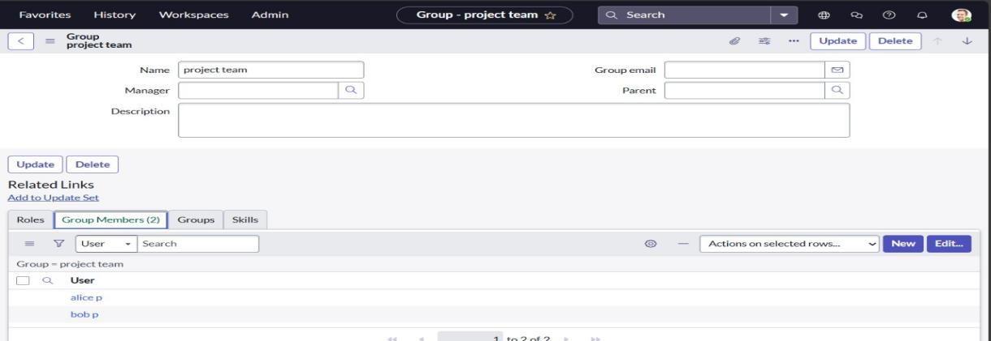

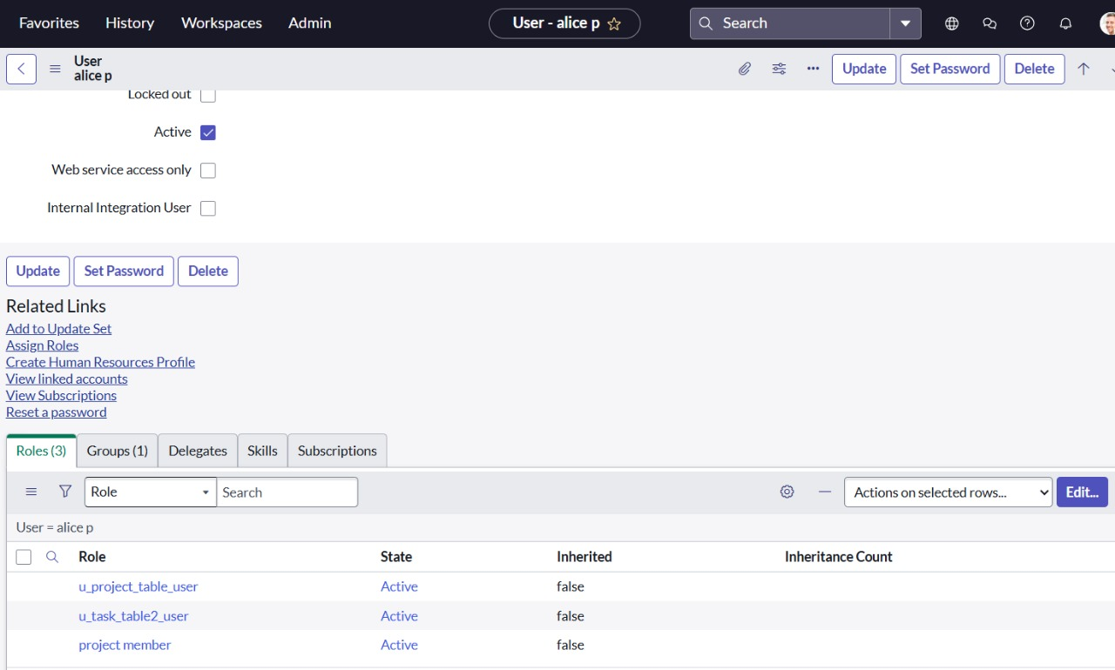

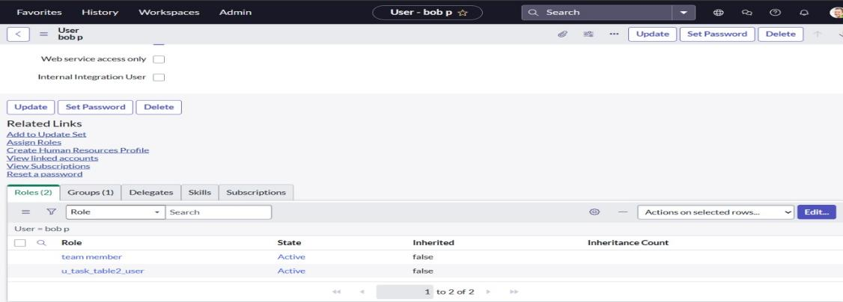

## Milestone 7: Workflow Implementation

* Designed a workflow for task management with the following states:

1. Task Created
2. Task Assigned
3. In Progress
4. Completed
5. Closed by Manager

* Used ServiceNow Flow Designer to automate transitions and set up notifications

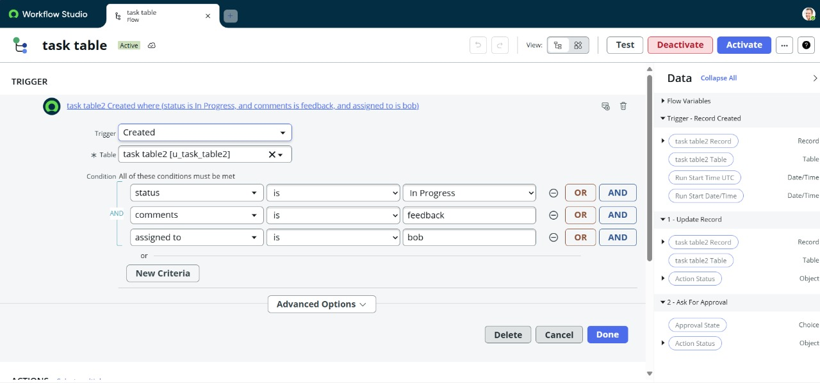

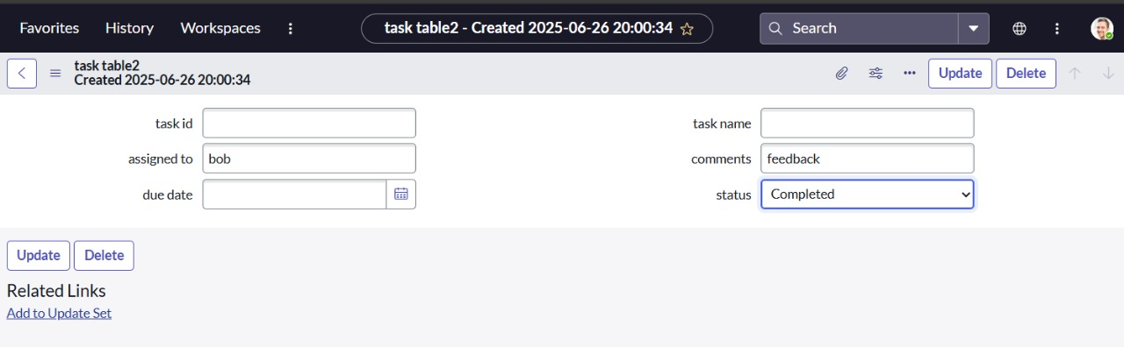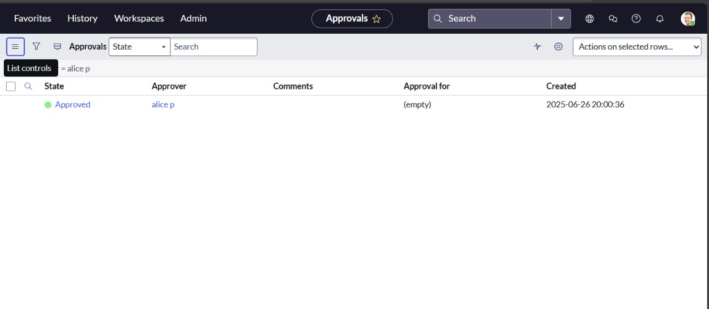

## Milestone 8: Business Rule Setup

* Created Business Rules to:

1. Prevent task reassignment by unauthorized users
2. Trigger alerts on status changes
3. Maintain logs of changes per user



## Milestone 9: Configure Relationships

* Linked Task Table with User and Role tables
* Created Related Lists to display task ownership under user profiles
* Enabled Manager-only visibility to closed/completed tasks

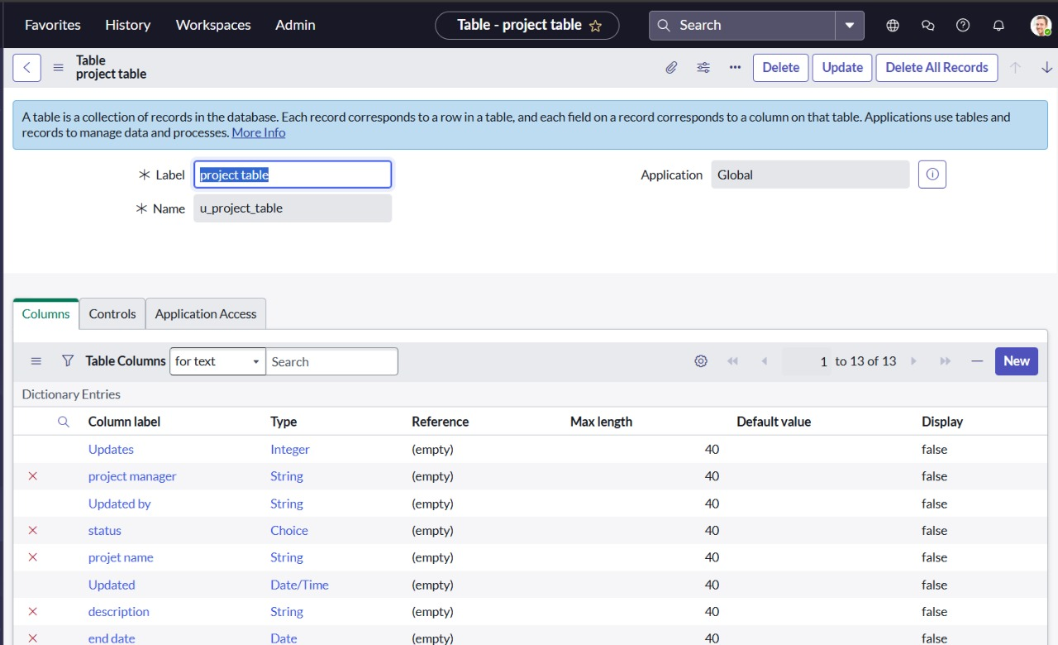

## Milestone 10: Testing & Validation

* Tested workflows by logging in as both Alice (Manager) and Bob (Team Member)
* Verified:

1. Bob could only update assigned tasks
2. Alice had full access
3. Status changes triggered alerts
4. Unauthorized actions were blocked

